Planning Assignment

Sarah Tedford
Faculty of Education, University of Victoria
EPHE 310 A02: Physical Education for General Classroom Teachers
Dan Geneau
November 28, 2020

Lesson: 1 of 4  Topic: Dribbling  Grade(s): 3-6  Materials/Resources:  - Cones, basketballs  Parts of the lesson  Set up cones (if needed) before class  Activities:  - Warm-up (electric fence)  - Stationary drills  - Dribble lines  - Dribble knockout (culminating activity) |  | Learning Objectives: TSWBAT  Cognitive  - Students will follow the rules and listen to instructions  - Students will learn strategizing – for how they may want to try and tag people or escape being tagged  - Students will listen to the directions of how to dribble and the explanation of the drills  Psychomotor  - Students will be able to run, dodge, reach, and work on agility  - Students will learn to dribble properly with one hand  - Students will start working on pivoting and changing directions by planting a foot and pushing off the ground  Affective  - Students will be able to work/play well with others (team work)  - Two taggers working together to tag someone  - Students will be honest and play fairly  - Not become frustrated when tagged  - Students will learn to be patient as they learn
Introduction  Hello class! Today we are going to be starting our basketball unit. Have any of you played basketball before?  After our warm up, the first skill we will be working on is dribbling. Can everyone please stand up so we can get started? | Time |  | Teaching cues
Lesson Description  Warm-up – Electric Fence  - Two students stand on a line in the gym (or in between two rows of cones about 1.5-2 feet apart)  - The rest of the students stand at the wall on one side of the gym  - When the taggers say “electric fence”, the students must try and run across the gym to the other wall without being tagged as they cross the line  - The students on the line cannot leave the line and must run back and forth along it when trying to tag other students  - As students get tagged, they join the line of taggers  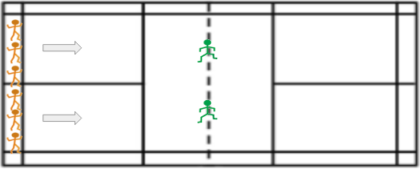  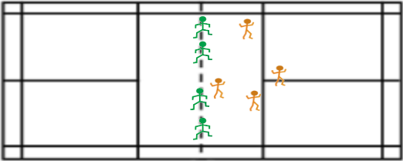  Skill being taught: Dribbling  - Learn what dribbling is and rules  - One hand on ball at a time  - Cannot stop and then start again  - Teach proper form/stance when dribbling  Stationary drills  - Ball slaps  - Slap the ball from one hand to the other to warm up hands  - Straight arm finger taps  - Keep elbows locked, tap the ball back and forth between hands  - Wraps – around the world  - Move the ball around your body, starting at your head, then move to waist, then ankles, then repeat  - Wraps – figure 8 around legs  - Move the ball in between and around your legs in a figure 8 motion  - Pound dribble – waist high (right hand)  - Dribble as hard as you can without going higher than the waist  - Pound dribble – waist high (left hand)  - Pound dribble – shoulder high (right hand)  - Dribble as hard as you can without going higher than the shoulder  - Pound dribble – shoulder high (left hand)  - Crossover dribbles  - Pass the ball back and forth between your hands in front of your body  - 3-dribble crossover  - Pound the ball 3 times before crossing it over to the other side  - Front V-dribble (right hand)  - Dribble ball from side to side in the shape of a ‘v’ in front of your body  - Front V-dribble (left hand)  - Side V-dribble (right hand)  - Dribble ball backwards and forwards beside your body in a ‘v’ shape  - Side V-dribble (left hand)  - *Behind the back dribble  - Cross the ball continuously behind your back  - *Scissors – alternating between the legs  - Start with right foot forward and left foot back  - Cross ball between your legs and jump to switch your feet so you can cross the ball back to the other side  - Every time you go through the legs you switch feet  Dribbling lines  - Every student starts on the baseline  - Students will be split into different lines with a basketball at the front of each line  - The teacher gives each line a different dribble movement to do as they jog, zigzagging up the court and back (each line will rotate through all the movements)  - Right/left hand  - Crossovers  - Dribble low  - Dribbling backwards  - *Behind-the-back  - *Through-the legs  - Once the student gets back, they pass the ball to the next person in line and go to the back of the line while the next student starts going  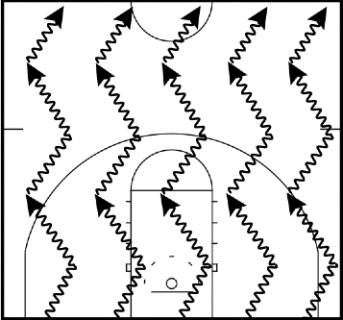  Culminating activity:  This activity ties everything together that has been taught and practiced during this lesson. It has the students use the proper dribbling form, while also having them move around the gym, as well as switching hands (requiring other dribbling skills, like the crossover).  Dribble knockout  - The students all start with a basketball and dribble around half of the gym (or the section of the gym that the teacher specifies)  - They must protect their own ball while trying to go after their classmates basketballs to knock them out of bounds  - They cannot push the student, but they can reach to try and hit the basketball away  - If you lose control of your own ball or accidently dribble out of the lines, you are out  - You are allowed to try and save your basketball after it is knocked away from you, but you cannot use two hands or pick it up once it stops bouncing or goes out of bounds  - As students get knocked out, make the area they are allowed to dribble in smaller (such as moving them inside the three-point line or the centre circle) so the students are closer to each other  - After the students are out, have them stand outside of the boundaries and practice their stationary dribbling  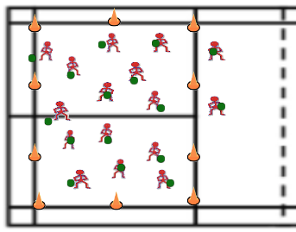 | 10 minutes  Each for 30 seconds – total 6-10 minutes  10 – 15 minutes  10 – 15 minutes |  | - Ask them to list some safety concerns  - Make sure no one runs into each other  - Do not push each other when trying to get passed taggers  - Tripping and falling  - For taggers, make sure they do not tag/push too hard  - Remind students to tag gently and not run into other students  - Remind them that it is okay to be tagged and to not win every game  - The whole gym is used, but the boundaries for the taggers are to stay on the line (must have one foot on at all time)  - If there are a lot of students, the warm up can be modified by using two lines with two people on each, so there are 4 taggers  - Make sure students know that messing up is okay and it means they are pushing themselves hard  UDL Checkpoint 5.1  Ask them to list some safety concerns:  - May hurt if hit with the ball so be aware of surroundings/other students  - Watch where you are running to not trip and fall  Make sure students:  - Are standing in athletic position with feet apart, knees bent, and back close to straight  - Have their arm up to protect the ball  - Have their eyes up/looking forward  - Use their finger tips and not their whole palm when making contact with the ball  - Know they only have to go as fast as they can  - Know they can stop and start as much as needed  - Know that they just have to try their best and that some of the drills are challenging  - Do a demonstration of each stationary dribbling drill and show them the proper athletic position  - Ask if any student would like to volunteer to demonstrate  Modifications:  - For beginners and younger students, they can use two hands every few dribbles as they learn, making it easier to get used to and figure out  - They can also look down when needed instead of looking up all the time  - To make it harder, the students can try the behind the back and the scissors dribbling  Make sure students:  - Keep their arm, head, and eyes up while dribbling  - Develop good technique, before they focus on using their outside foot to push off the ground to change direction/make a move  - Pass the ball to the next person in line quickly when they get back to the start to keep the drill moving  Modifications:  - To make it easier, the students can just dribble to half court and harder would be full court  - If needed, students can stop and start again to make it easier and reset  - They can walk to make it easier or run to make it harder  * = Harder dribbles  Have students list some safety concerns:  - Be careful not to hit the students when trying to hit the ball  - Do not push the ball into other students  - Be aware of your surroundings when dribbling, trying to knock the ball out, trying to save your ball, and when moving around the gym so you do not hurt another student  Modifications:  - To make it harder, make the area they must dribble in much smaller so they are quite close together  - They could also have to dribble with a specific hand and if they use the other hand, they are out  - One other way to make it harder could be to have the students that are out stand around the boundaries and reach in to try and knock away the students basketballs who are still in  - To make it easier, the students can have more than one life, so they can continue playing after getting out  - They could also be allowed to step a little bit out of the lines  - Tell the students that it is okay of they get knocked out because it is just a game, and tell them that they will play another round if there is enough time  - Make sure they are dribbling in the proper form with their arm, eyes, and head up
Closure

Proper form/positioning:
- What does proper dribbling form look like?
- Feet apart, knees bent, arm up to protect the ball, eyes and head up
- Use their finger tips, not palm when making contact with the ball

Appendix

Universal Design for Learning Inclusive Episode

UDL checkpoint 5.1 – Use multiple media for communication

This can be used to communicate clear instructions to the class. It can help clarify what they need to do in different parts of the lesson. Using multiple types of media can be very helpful for some students who learn and understand best with different forms of communication. In this lesson, the teacher can use speech, text, and videos during the stationary dribbling drills to help demonstrate and make it clear what the students are trying to do. It will help them visualize the skill and different types of dribbles they are practicing. The speech will help those students that are auditory learners, and the text will also help visual learners, and can be written down for the whole class to refer back to as a reminder.

Task Analysis

Systematic Task Analysis: Dribbling

- Hold the ball with two hands.
- Move ball to the right or left side of your body, depending on which hand you will be dribbling with.
- Bend your knees to stay low to the ground and have your feet spread apart to help with balance.
- Use your fingertips (not your palm) to start bouncing the ball, and have your fingers spread out.
- Only use one hand on the ball at a time, otherwise it will be a double dribble, which is not allowed.
- Keep your hand on top of the ball to maintain control and keep dribbling.
- Keep your head and eyes up, so you can look around and see the court and the other students/players.
- Have your arm up when dribbling to protect the ball from the defender.
- Incorporate dribbling into your movement by starting to walk or run while dribbling.
- Do not stop dribbling the ball because you cannot start again after picking it up.

Assessment – while the students are practicing the skill building exercises, the teacher can fill this out

Teacher Observation Checklist
Dribbling Position | Working on:  - Getting low – feet apart, knees bent  - Using fingertips – spread fingers apart, no palm  - Keeping eyes and arm up  1 2 3 |  |  | Comments
Student Name

References
50 Basketball Dribbling Drills (Develop an Amazing Handle). Basketball For Coaches. https://www.basketballforcoaches.com/50-basketball-dribbling-drills/.
73 Basketball Drills and Games for Kids (2020 Update). Basketball For Coaches. https://www.basketballforcoaches.com/basketball-drills-and-games-for-kids/.

