Story Drama Lesson Plan
EDCI 305A
Linnea Leist, Olivia Anacleto, & Sarah Tedford
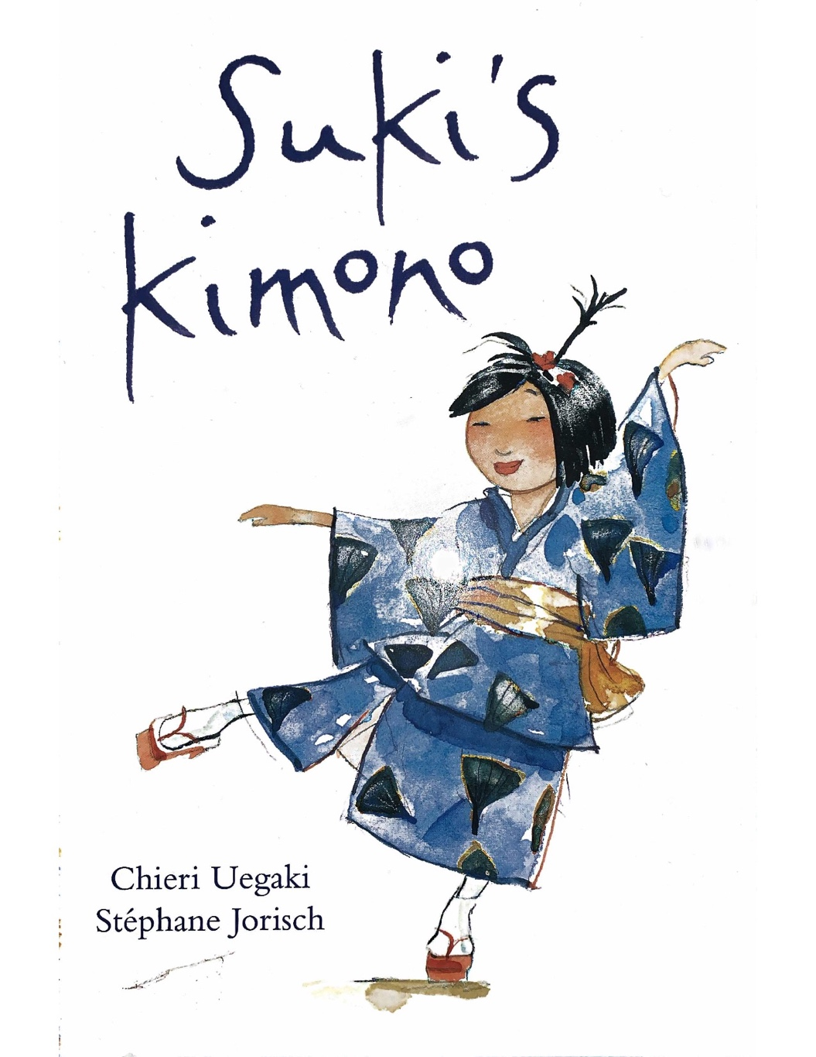

Suki’s Kimono, Written by Chieri Uegaki & Illustrated by Stéphane Jorisch
Kids Can Press, 2003, Toronto, ON.

Summary of Book
Suki’s Kimono is a great children’s book depicting the importance of savouring one's special possessions. This story provides a retelling of Suki’s summer adventure with her Japanese grandmother. Her adventure included receiving a traditional kimono, attending a festival, and dancing with the many townspeople. Then, to recall this important event, Suki decides to wear her new kimono on the first day of school. Suki’s sisters try to talk her into wearing something “newer” and “cooler,” but Suki decides to wear what makes her happy. Once at school, Suki is initially laughed at because of her kimono. However, when asked about her summer, Suki breaks out into the traditional dance that she saw at the festival. Soon, the entire class is smiling and applauds Suki for her incredible display. Overall, this story shows us how to embrace our special experiences and possessions (Uegaki, 2003).

Why Did We Choose This Story?
- Story has a lighthearted nature and capability to teach a valuable lesson.
- Provides a message of embracing one’s truest self.
- Highlights multiculturalism and cultural differences.
- Emphasizes the importance of being unique.
- Displays the importance of sharing special elements and aspects that make you happy.

Grade Level: 3

Learning Outcomes
- “Use imagination, exploration, and reflection to create drama” (BC Ministry of Education, 2010): Students share their creativity and cultural exploration around Suki’s adventure.
- “Use voice to convey intended ideas or feelings” (BC Ministry of Education, 2010): Students participate in-role as the characters in the book to portray their thoughts.
- “Use movement and their bodies to convey intended ideas or feelings” (BC Ministry of Education, 2010): Students express the thoughts of the characters by using their bodies to create a tableau.

Cross-Curricular Connections
- Social Studies: This story introduces multiculturalism and immigration, as well as the importance of learning about aspects of other cultures to learn new things.
- Art: The story includes beautiful illustrations, bringing attention to the various colour palettes and types of art. Also, students participate in art-related activities, such as designing their own kimono.

Key Understandings and Questions
- Why is it important to be yourself and share what makes you happy?
- It is important to embrace and be proud of your culture, no matter what others say.

1. What Makes You Who You Are? 5 minutes
Grouping: Individual
Strategy: Warm-up (pre-reading activity)
Administration: Paper and pencil
Focus: To start thinking about how everyone is their own, unique person.

Teacher: Today, we will be reading the story Suki’s Kimono, and participating in various drama activities to deepen our understanding of the story’s message of staying true to yourself. I will stop reading the story at certain points, and we will participate in a drama activity. To begin, I want you all to all take a few minutes to make of list of things that make you, you. It can be about your physical characteristics, personality, family, cultural, experiences, likes or dislikes, goals, or anything else you would like to write about yourself. [They write].

Students write for 3 or 4 minutes.

Your time to write is finished. Would anyone like to share any points they wrote down?

Choose 2 or 3 students to share.

Now, let’s start reading Suki’s Kimono, by Chieri Uegaki and Stéphane Jorisch.

Read page 1-4 of Suki’s Kimono. 1 minute

2. What to wear? 6 minutes
Grouping: Whole Class
Strategy: Conscience Ally
Administration: Space to form a large circle with all students.
Focus: To think about how Suki and her sisters feel about Suki’s kimono.

Teacher: Now that we have read a few pages of the story, we will be participating in our first drama structure. This activity, called conscience ally, will require you to think quickly and consider how you feel when choosing your first day of school outfit. This will allow you to consider how Suki felt while choosing to wear her kimono. Now, can everyone please form a circle. [They do].

Can I please have one volunteer stand at one end of the circle. [Someone volunteers – will be volunteer 1]. Thank you, you will be Suki. Can I please have two additional volunteers to be Suki’s sisters, Yumi and Mari. [Two students volunteer]. All three volunteers will have no lines and you will slowly walk around the circle.

The rest of you will take turns saying one or two words about how the characters feel about Suki’s first day of school outfit. So, when Suki [volunteer 1] walks past you, you will say a word about how she feels about her outfit. We will repeat this for the sisters’ thoughts. Make sure only one student speaks at a time, so we can hear everyone’s thoughts. This will be accomplished by passing around a talking stick to those willing to share, and the volunteers will need to walk really slow around the circle. Any questions?

Make sure students understand what to do. Address any concerns before beginning.

Volunteer 1[Suki] begins to walk very slowly around the circle and classmates [in role] say their thoughts about how Suki feels about her outfit. Then Volunteer 2 and 3 [Yumi and Mari] do the same, and classmates [in role] share the sisters’ thoughts about Suki’s outfit.

Thank you. It sounds like Suki’s outfit raised a lot of thought for both herself and her sisters. Are there any other thoughts you may have while choosing a first day of school outfit? If you were all to be meeting for the first time, what would you think of other students’ outfits? Please take a minute to consider these questions individually.

Students consider these questions and make their silent observations.

Now, let’s continue reading the story.

Read pages 5-12 of Suki’s Kimono. 2 minutes

3. Be a Designer 10 minutes
Grouping: Groups of 3-4
Strategy: Designing
Administration: Outline of kimono (see p. 11), pencils, coloured felts
Focus: To think about one’s culture and/or a favorite memory, similar to how Suki thinks about her culture.

Teacher: Suki decides to wear her kimono to the first day of school. To Suki, her kimono is a symbol of her culture and it holds special memories of her summer adventures with her grandmother at the festival. Think about some special aspects of your family’s culture, or a special memory you have that makes you smile. Then, think about some objects or images that represent your culture or memory.

In groups of 3 or 4, you will be designing your own kimono, just like Suki’s. Each group member can choose one special symbol to add to the kimono, and I would like you to share why this symbol holds a special place in your heart.

Teacher distributes kimono outlines,

Teacher: Take turns adding your symbol to the kimono. Once each student incorporates a piece of their culture/ memory, you will have a beautiful piece of art representing various cultures. Don’t forget to add bright and fun colours to your kimono, just like the beautiful colours in the book’s artwork. [Students design their kimonos].

While students design their kimono, circle the classroom and remind students to share the importance of their symbol with their group. This promotes sharing different perspectives and developing an understanding of other cultures.

Now that you have had a chance to design your own kimono, let’s continue reading the story.

Read pages 13 - 26 of Suki’s Kimono. 5 minutes

4. Into the Story 8 minutes
Grouping: Individual
Strategy: Writing in Role
Administration: Pencil and paper
Focus: To imagine what the characters may be thinking during the dance scenario.

Teacher: Imagine you are the students in the classroom. What would you think if one of your classmates started sharing their cultural dance in the middle of the class? I would like you to imagine that you are one of the following characters: Suki, her friend, the teacher, or one of the classmates that was laughing at Suki. Spend the next few minutes and write about how one of those characters are feeling during this scene. [They write].

Students write for 5 minutes.

Now that you have had a chance to write about how you would feel as a character in the story, would anyone like to share a portion of their writing? Could we please have at least one person share from Suki’s perspective, one from Suki’s friend, the teacher’s perspective, and one of Suki’s classmates. [Students volunteer to share a part of their writing].

Sharing session occurs for approximately 3 minutes.

Great work writing in role and considering the thoughts of the characters. Now, let’s continue the story.

Read page 27 of Suki’ Kimono. They story is over. 1 minute

5. Create This! 9 minutes
Grouping: Groups of 3
Strategy: Tableau and Tapping In
Administration: Open space
Focus: To think about how Suki and her sisters feel after the first day of school.

Teacher: Suki had an amazing first day of school and is so happy she decided to wear her kimono. On the other hand, her sisters were too focused on other peoples’ thoughts and were not happy when no one noticed their outfits. This is why it is so important to do what makes you happy, and not base your happiness on what other people think. Now, I would like everyone to get into groups of 3. [They do].

Students shuffle around the class to create groups.

I would like you to create a tableau, which is a frozen picture with your bodies. You will recreate the scene where Suki gets off the bus and is thinking about her successful back to school outfit, whereas her sisters are upset about their outfits. One student will be Suki, and the other two will be her sisters. I also want you to consider what the characters are thinking in this situation. [Students begin to create their tableau].

Give students 7 minutes to create their tableau.

Teacher: Please stay frozen in your tableau while I introduce the next portion. I will walk around the class, and “tap in” on a few students. When I place my hand on your shoulder, I would like you to share what you are thinking at this moment of the story. Any questions?

Teacher walks around the class and chooses 5 students to share their thoughts, making sure the students share the opinions of both Suki and her sisters.

6. Be Proud of Who You Are 8 minutes
Grouping: Partners and Whole Group
Strategy: Reflection
Administration: None
Focus: To continue thinking about being true to whom you are.

Teacher: This was a powerful and meaningful story that made us all think. I would like you to all turn to a partner beside you and talk about what you learned and what this story means to you. Also, discuss what you experienced and learned through the story drama activities. Try and think about the specific activities we did and how they helped your understanding of people’s differences.

Here are some questions that may help with your discussions:

- Do you have any personal connections that you can make to this story? Have you experienced anything similar to what Suki experienced?
- What would you say to someone to help them care less about what other people think of them?
- Why do you think people make fun of and judge what other people have and wear?
- What is something(s) you are proud of that is related to your culture? Is there anything you have or do with your family, such as a tradition, you would like to talk about?

At the end, we are going to come back together as a class and share some of the ideas that were discussed to conclude this story drama on Suki’s Kimono. [Students reflect].

After the reflection activity, students can complete the self-assessment.
Self-Assessment: Suki’s Kimono Story Drama 5 minutes

Name: ____________________________ Date: ____________________________

For each statement, place a check mark in the column that you think best describes your thoughts and feelings about the Suki’s Kimono Story Drama.
 | Agree | Neither Agree nor Disagree | Disagree
1. I enjoyed the Story Drama.
2. I tried my best with the activities.
3. I tried something new this class.
4. I learned about being more accepting of people’s differences.
5. The “Writing in Role” activity helped me get inside the characters head and understand more of what they were thinking.
6. I felt comfortable sharing my ideas for the activities with my classmates.
7. This story helped me understand more about what make me who I am.
8. The “In-Role” activities helped me consider how the characters felt in the story.
9. The “Designing” activity helped me think about my culture and/or favorite memory.
10. Suki’s Kimono was a fun story drama.
Circle three words that describe your experience and success with this story drama. Then underline three that you would like to work on for next time.

Trustworthy Leader Cooperative Good Listener
Confident Risk Taker Imaginative Curious
Communicator Problem Solver Inclusive Engaged

Please write 2-3 sentences below explaining how this story drama is important for you.
__________________________________________________________________________________________________________________________________________________________________________________________________________________________________________
If you could change anything about this process, or story, what would you change? Why?
____________________________________________________________________________________________________________________________________________________________
(Swartz, 2014)
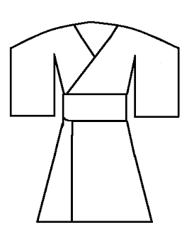
Kimono Outline for Activity 3

(Broadhurst, 2013)

Materials
This story drama requires the book Suki’s Kimono, by Chieri Uegaki and Stéphane Jorisch, which can be purchased from Amazon. It is recommended to also have a dictionary or word definitions list to define words students may not know. Some of these words could include kimono, O bachan, and geta.

Activity 1: Paper and pencil
Activity 2: None
Activity 3: Large paper with outline of kimono, pencils, coloured felts
Activity 4: Paper and pencil
Activity 5: None
Activity 6: None

References
BC Ministry of Education. (2010). Arts education drama k-7. https://www.bced.gov.bc.ca/irp/course.php?lang=en&subject=Arts_Education&course=Arts_Education_Drama_K_to_7&year=2010
Broadhurst, S. (2013). Design your own kimono. https://www.pinterest.ca/pin/230246599674530155/
Miller, C., & Saxton, J. (2016). Into the story 2: More stories! More drama! Intellect ltd.
Swartz, L. (2014). Dramathemes. Pembroke Publishers.
Swetzier, K. (2020, March 27). Suki’s kimono read aloud [Video]. YouTube. https://www.youtube.com/watch?v=ZfBG10KCEDk
Uegaki, C. (2003). Suki’s kimono. Kids Can Press Ltd.

