Olivia Anacleto and Sarah Tedford
EDCI 307A A02 – Art in the Elementary and Middle School Classroom
Image Development Strategy Lesson Plan
March 12, 2021

Group Members: Olivia Anacleto and Sarah Tedford
Grade Level: Grade 4
Big Idea:
- Artists experiment in a variety of ways to discover new possibilities.
Element of Design: Shape
Aspect of the Element of Design: Shapes can be geometric or organic.
Image Development Strategy: Multiplication

Prior Knowledge:
The students would have participated in a “shape animal” activity. As a class, they would have looked up a few animals online and identified what organic and geometric shapes they saw. They would have sketched these shapes to practice drawing organic and geometric shapes. After sketching their shapes, the students would have chosen a few shapes to put together to create a shape animal. This activity would introduce students to the element of design and the aspect of the element of design. It also gives them the ability to apply their knowledge of shapes while incorporating their personal interests (i.e., their favourite animal) (Shape Cats, n.d.).

First Peoples’ Principle:
- Learning is holistic, reflexive, reflective, experiential, and relational (focused on connectedness, on reciprocal relationships, and a sense of place).

Discovery Opening for Image Development Strategy:
Briefly explain multiplication to students: multiplication uses repetition to copy part of an image, or an entire image.
Before participating in the discovery activity, take the students on a nature walk. Since mandalas are generally inspired by nature, the students can explore their surroundings to become inspired by objects they connect to and potentially find an organic shape they may include on their mandala. Encourage students to look for objects in nature that may demonstrate multiplication (i.e., flower petals, pinecones, etc.). While the whole class will participate in this nature walk, including an element from the walk on their art piece is optional. However, it may help students think of organic and geometric shapes, as well as some elements of multiplication, to include on their mandala if they were having trouble.

Curricular Competency:
- Create artistic works collaboratively and as an individual using ideas inspired by imagination, inquiry, experimentation, and purposeful play.

Discovery Activity for the Element of Design: Mandalas
Materials:
- White paper
- Pencil
- Scissors
- Ruler
- Markers and/or pencil crayons
Activity Instructions:
- Hand out one piece of white paper to each student. Pre-cut the paper into circles so they are all the same size and shape.
- Have the students fold the paper in half to make a crease through the paper, open it up and fold it again the opposite way, then fold the paper two more times to create eight (roughly) equal sections.
- Draw over the creases with the pencil or black marker to clearly separate the different sections.
- Explain to the students that they will draw shapes/patterns/objects in one of the sections. They will think of the objects or parts of nature that they observed/connected to/believe expresses themselves from when they went on the nature walk, especially elements in nature that demonstrated multiplication. They can then decide whether or not they would like to include a drawing of that in their mandala.
- When they are done and happy with the drawings, they will copy the design into the other seven sections, multiplying the work.
- When they have finished multiplying the work, they can add colour using markers or pencil crayons, if they choose to do so.
- Let the students know that while creating their mandalas, there is no specific way they need to do it. They should focus on play, experimentation, and including shape/multiplication in their art.

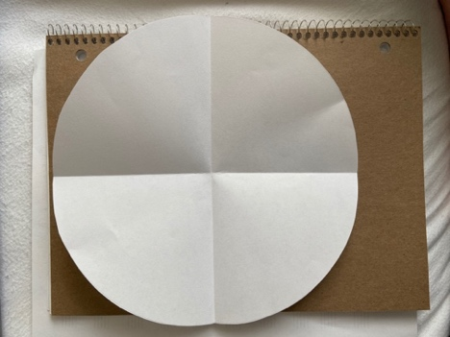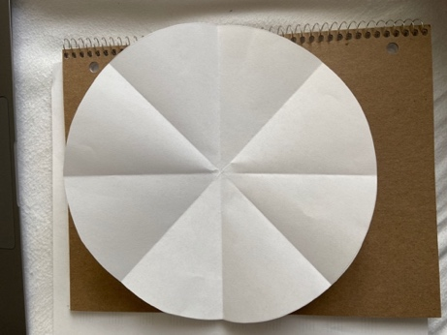
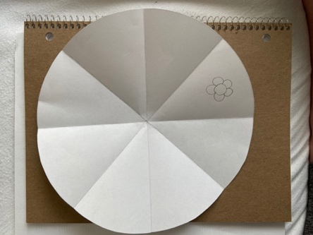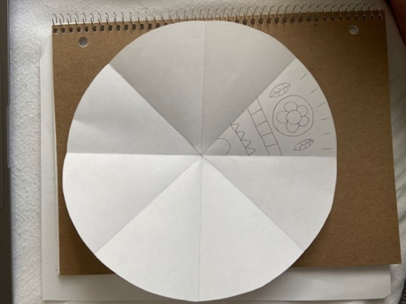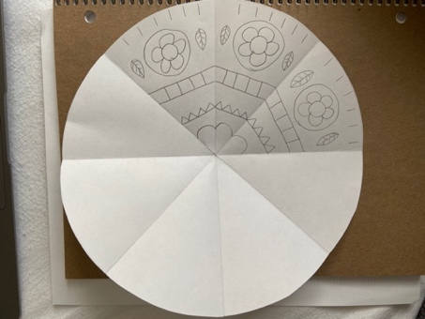

Formative Assessment: Non-judgmental Critique
- Are there any organic and geometric shapes that stand out to you?
- Can you see any shapes that may have been inspired by our nature walk?
- Can you see any mandalas that include multiplication inspired by our nature walk?
- What mandala stands out to you for showing multiplication very well (for example, they copied and repeated their patterns almost identically)?

Consolidation:
Curricular Competency:
- Describe and respond to works of art and explore artists’ intent.

Critical Analysis Process:
Artist: Stephen Meakin Name of Work: The Wild Rose
Date: 2018 URL: https://www.themandalacompany.com
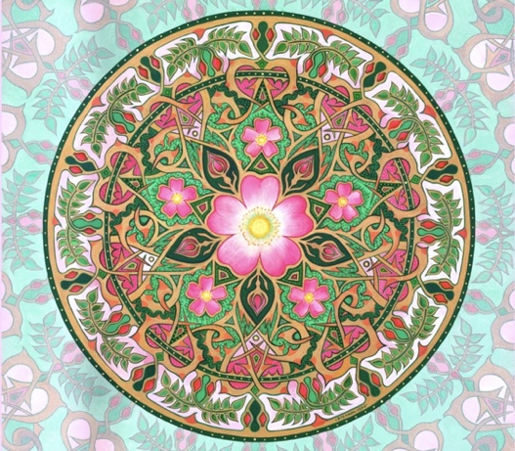
1) Initial Reaction
- How does this art make you feel?
- What was your first reaction when you saw this art? Do you like it? Why or why not?

2) Description
- What do you see in this mandala?
- Does this mandala remind you of any art or any objects you have seen before?

3) Analysis
- Do you see any organic or geometric shapes?
- Where do you see multiplication on the mandala?

4) Cultural Context
- Mandalas are circular-shaped, and they were originally created for Hinduism and Buddhism, which are religions based out of India. A lot of mandalas are created using sand as well, which is a part of their spiritual practices.
- *If time allows, show the students a small clip of this video:
  - https://www.youtube.com/watch?v=rfl-UCZr2-g&t=10s
  - Watch from 0:10 to about 1:45 (if it is too long for the students to watch, it can be put on x2 speed, so they can still see the whole time-lapse of the mandala being created).
- Mandalas include the repetition of specific parts (multiplication) to show that life is never ending.
- Stephan Meakin’s mandalas are inspired by geometry (geometric shapes). He says that math can be found in nature.
- As a kid in school, Stephen Meakin would stare out the classroom windows to look at nature. So, seeing nature is a big part of what inspires his mandalas. This piece of art was inspired by nature, which is why the flowers and organic shapes have been included.
- Questions:
    - What did you learn about this artist that you can see in their work?
    - Look closely at the shapes in this mandala, do you think they mean anything specific?

5) Informed Point of View
- How do you feel about this piece of art now?
- Can you now see how multiplication is used to show the meaning of the mandala?

Formative Assessment:
With a clipboard, walk around the class while the students are working on their art. Ask the students if they participated in the critical analysis (check off their name on the clipboard if they did). If they did not get the chance to participate, ask them a couple of questions about the art. So they can still see the art and reference specific points, you can have the artwork displayed on the document camera, or you can have a printed out version as well. This will allow all the students to have the chance to participate in the critical analysis process, even if they did not feel comfortable sharing their thoughts with the entire class.
If you noticed that a student did not participate, but says that they did, you can ask them one of the questions anyways. They do not have to talk about the art if they do not feel comfortable, they can simply point to specific elements (i.e., organic/geometric shapes or multiplication), if that is easier.
- How do you feel about this piece of art?
- Can you point out any geometric/organic shapes, or some parts of the art that show multiplication?
References
Dartmouth. (2011, January 28). The mandala of compassion at Dartmouth. [Video]. Youtube. https://www.youtube.com/watch?v=rfl-UCZr2-g&t=10s
Nguyen. (2015, October 19). Marker mandalas (4th). Art with Mrs. Nguyen. https://www.artwithmrsnguyen.com/2015/10/marker-mandalas-4th.html
Sang, K.L. (2018, November 24). Art of the star makers. Campfire Convention. https://campfireconvention.uk/guilds/art/art-star-makers
Shape Cats. (n.d.). The Art of Education. https://www.pinterest.ca/pin/515451119833870493/
The Mandala Company. (2020). Art of mandala with artist and designer Stephan Meakin MA. https://www.themandalacompany.com/

